Hibernate ORM Mapping
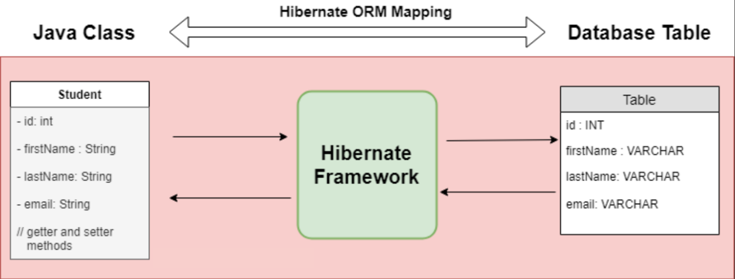
- 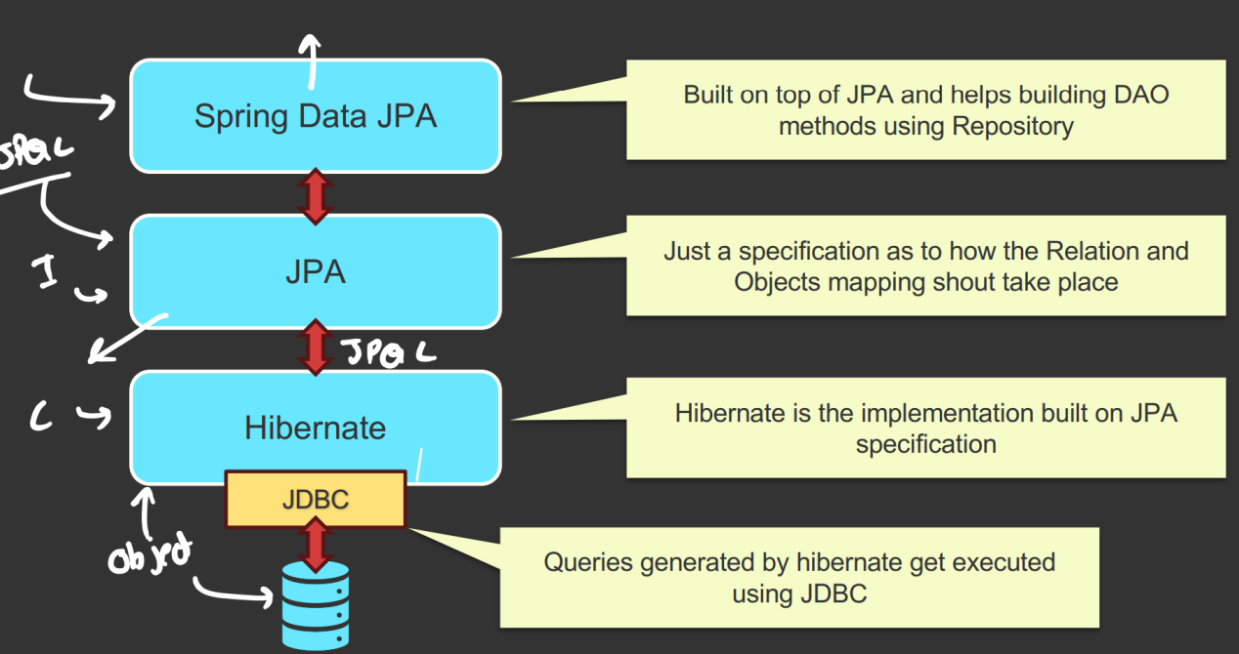
- With the help of driver of particular database, we can connect JDBC to it.
  - Inside JDBC, we need to write SQL queries that will be supplied to Database.
- Then comes Hibernate, it is responsible for Object-Relational-Mapping (ORM).
  - It’ll convert the specific Java object to Database relational entities.
  - Hibernate is the implementation built on JPA specification.
- JPA is just a specification as to how the Relation and Objects mapping shout take place.
- Then it comes Spring JPA.
  - It is built on top of JPA and helps building DAO (Data Object) methods using Repository.
- We can write on top of Spring Data JPA that is high-level data manipulation methods. Or also we can write JPQL on JPA level.

The exact flow from Spring Data JPA to Database
- First Layer is SPRING DATA JPA
  - Built by Spring on top of JPA.
  - Contains:
    - JpaRepository interface (extended by user-defined repository interfaces).
    - SimpleJpaRepository class (contains method bodies of JpaRepository).
  - SimpleJpaRepository already has implementations of CRUD methods (defined inside EntityManager interface of JPA).
  - No method implementation injection at runtime.
  - Spring creates a proxy that forwards repository method calls to SimpleJpaRepository.
  - Dependencies like EntityManager are injected at runtime.
- 2nd Layer is JPA
  - Pure Java specification.
  - Defines annotations and interfaces like EntityManager.
  - SimpleJpaRepository calls methods of EntityManager.
  - JPA provides only contracts, no implementations.
- 3rd Layer is JPA Provider (Hibernate is mainly used)
  - Hibernate implements EntityManager interface.
  - Provides actual method definitions.
  - Generates SQL queries.
  - Passes SQL to JDBC.
- 4th Layer is JDBC
  - Java API for DB communication.
  - Executes SQL generated by Hibernate.
  - Sends SQL to database drivers.
- 5th Layer is Database Driver
  - Executes SQL on the database.
  - Performs actual DB operations.

- Hibernate
  - It is a powerful, high-performance Object-Relational-Mapping (ORM) framework that is widely used with Java.
  - It provides a framework for mapping an object-oriented domain model to a relational database.
  - It is one of the implementations of Java Persistence API (JPA) which is a standard specification for ORM in Java.
- JPA
  - It is a specification for ORM in Java.
  - It defines a set of interfaces and annotations for mapping Java objects to database tables and vice versa.
  - It itself is just a guideline, doesn’t provide any implementations. Implementation is provided by JPA Provider framework like Hibernate.

Common Hibernate Configurations
- spring.jpa.hibernate.ddl-auto=update/create/validate/create-drop/none (1)
  - Update: we want to update the table when we update the entity
  - Create: everytime we running the server, old table will be dropped and create a new.
  - Validate: the table that we have and entity that we have are matching or not
  - Create-drop: create table on running of server and drop that after stopping the server (not used in production)
- spring.jpa.show-sql=true (2)
  - If we want to see all the queries being generated underneath
- spring.jpa.properties.hibernate.format_sql=true (3)
  - The queries coming from the previous command (2) should be displayed after properly beautifying not in a single line.
- spring.jpa.properties.hibernate.dialect=org.hibernate.dialect.MySql5Dialect (optional) (4)
  - Defines the rule that hibernate will use to convert JPQL to queries.
  - Database are having their own dialect.
  - Its optional because it’ll pick the proper dialect by itself.

- There are multiple annotations for Entity objects
  - 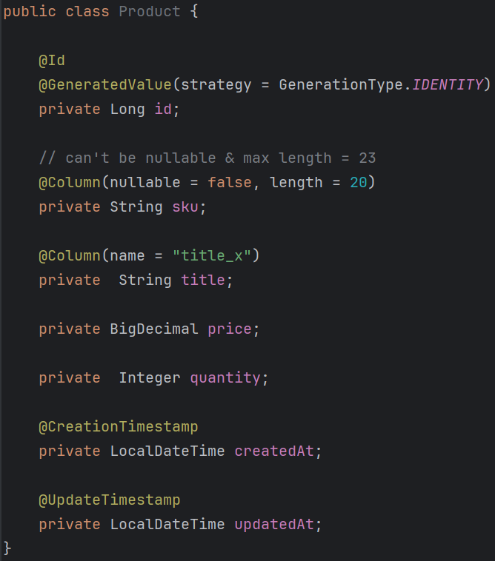
  - @Id, @GeneratedValue, @Column (change name, nullable true or false, length if it’s a string, etc etc), @CreationTimeStamp, @UpdateTimeStamp …etc
- @Table annotation
  - 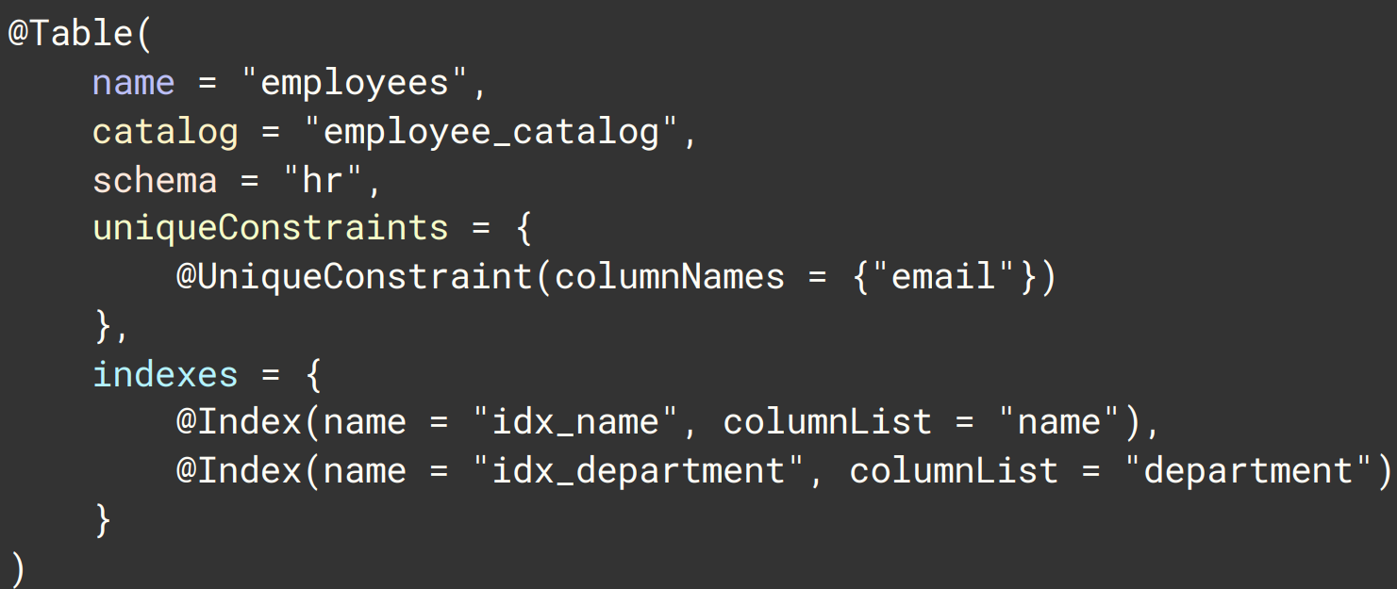
  - There is something called namespace in database.
    - auth.user, sales.user
    - Here both have the same table name "user", but they do not conflict because they belong to different namespaces (auth, sales).
    - In MySQL, the database acts as the namespace (mapped using catalog in @Table).
    - In PostgreSQL and Oracle, the schema acts as the namespace (mapped using schema in @Table).
    - So, schema and catalog both represent the same concept (namespace), and which one is used depends on the database.
    - UniqueConstraint is also an annotation :).
    - 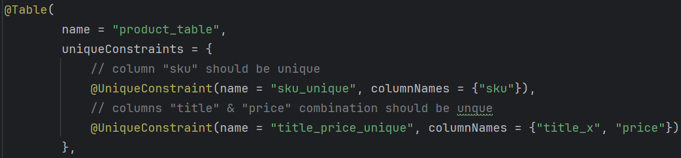
    - (title_x because we have changed the column name to title_x; previous image)
    - Name is used to provide a specific name to the constraint. Otherwise it’ll generate some random unique name for the constraint.
    - name is useful during debugging.
    - (without name)
    - (with name)
  - indexes
    - Here the columnList is a String not a List.
    - You should give comma separated column names.
    - 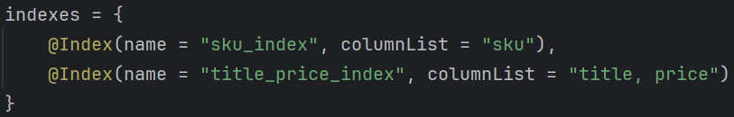
- NOTE: database should already be present. It’ll not create the database inside the server by itself.

- Indexing in database.
  - (JPA)
  - (SQL)
  - An index is a separate data structure that stores indexed column values along with row pointers.
  - It is not a normal table; it is created and managed internally by the database..
    - 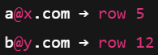
  - But this is not a normal table, it is created and managed by database itself.
  - Read queries are faster, but create, update, delete queries are slower as it needs to update the index table as well.

Spring Data JPA
- It is a part of the larger Spring Data Family.
- It builds on top of JPA, providing a higher-level and more convenient abstraction for data access.
- Spring data JPA makes it easier to implement JPA-based repositories by providing boilerplate code, custom query methods, and various utilities to reduce the amount of code you need to write.
- 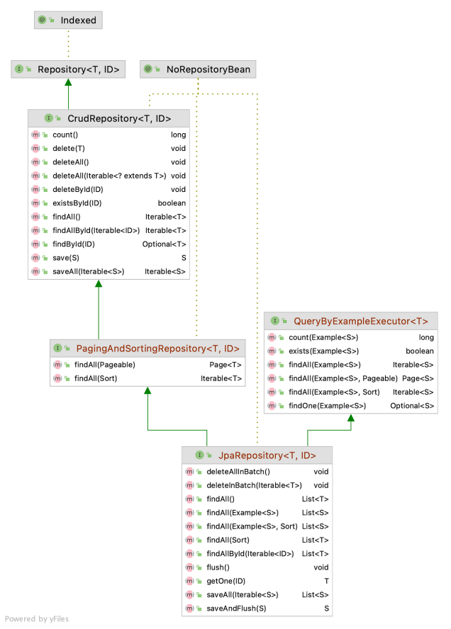
- SimpleJpaRepository class implements the JpaRepository interface. It contains implementation of all the methods of the JpaRepository and its parent interfaces.
- Key Features of Spring Data JPA
  - Repository Abstraction:
    - Provides a Repository interface with methods for common data access operations.
  - Custom Query Methods:
    - Allows defining custom query methods by simply declaring method names.
  - Pagination & Sorting:
    - Offers built-in support for pagination and sorting.
  - Query Derivation:
    - Automatically generates queries from method names.
- You’ll have to just write the method name in the Repository and no need to implement. It’ll be done automatically.
  - 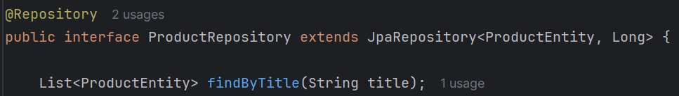
  - Just like this just write the method.
  - NOTE: If you remember the column name is title_x not title.
    - 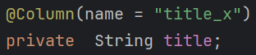
    - query generation takes place according to the Java object; not Database column; If you write findByTitleX then it’ll not work;

- Rules for Creating Query Methods
  - 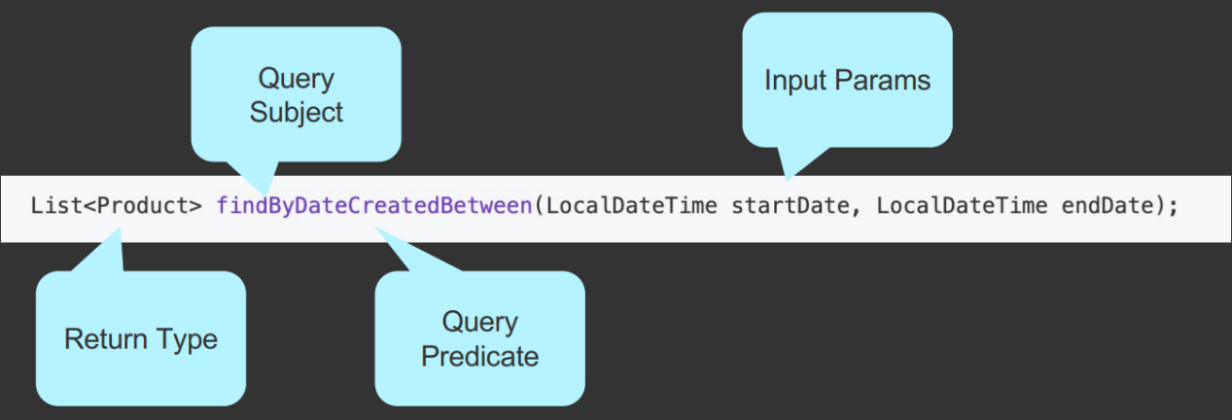
    - Return type will be mostly Entity, Optional<Entity> or List<Entity>
    - In the diagram, Query Subject is findBy, and Query Predicate is DateCreatedBetween.
  - The name of the query method must start with one of the following prefixes
    - find..By, read..By, query..By, get..By
    - Examples: findByName, readByName, queryByName, getByName
  - If we want to limit the number of returned query results, we can add the First or the Top keyword before the first by word.
    - Examples: findFirstByName, readFirst2ByName, findTop10ByName
  - If we want to select unique results, we have to add the Distinct keyword before the first By word.
    - Examples: findDistinctByName or findNameDistinctBy --- both are same
  - Combine property expression with And and Or
    - Examples: findByNameOrDescription, findByNameAndDescription
  - For more, refer to the link: query keyword reference
- A few examples:
    - To get all the items that were created after a particular time.
  - findByQuantityGreaterThanAndPriceLessThan(int quantity, int price)
    - The argument orders should be same as the query.

- Writing JPQL query directly
  - @Query annotation is used to write the JPQL query.
  - ?1 , ?2 , ?3 etc are used to get the argument from the method. In the above image
    - ?1 means title
    - ?2 means price
  - Instead of ?1 ?2 you can also write :title and :price
  - NOTE: JPQL should be written according to Java object (inside Entity), not according to Database table/column name.
    - In database the table name is product_table as I have mentioned inside the @Table annotation, but the entity name is ProductEntity, so we need to pass ProductEntity in the JPQL.
    - Also, in the database the column name is title_x as I have mentioned title_x in the annotation @Column, but the field name is title in side ProductEntity class. So we need to pass title in the JPQL query.
    - And also, we are not writing select * just like SQL, rather we are writing select e. here select * will not work.

Sorting & Pagination
- OrderBy is used to Sort.
  - Instead of findAll, here we need to write findBy.
  - It’ll get all the rows and sort them according to the price. OrderByPrice.
  - It’ll also do the same, but it’ll sort in reverse order.
  - Asc is for ascending, Desc is for descending order.
- But it is not proper; because if we want to sort by some column, then for each column we need to write one method each. For example findByOrderByPrice, findByOrderByTitle, findByOrderById …etc
  - For this we can use Sort class.
    - Here we need to get the argument of type Sort.
  - 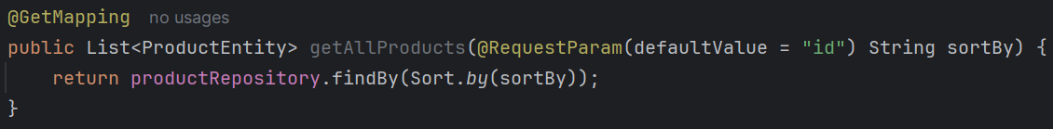
    - We can call that method like this. Passing one Sort object.
  - Now, the API call should be made confirming according to which column it has to be sorted and its done.
    - like this
    - If the sortBy column is same, then it’ll further sort according to “price”. like this we can give multiple properties.
    - You can give the direction like this as well.
    - If you want different direction i.e. ASC, DESC for different columns then use like this.
- 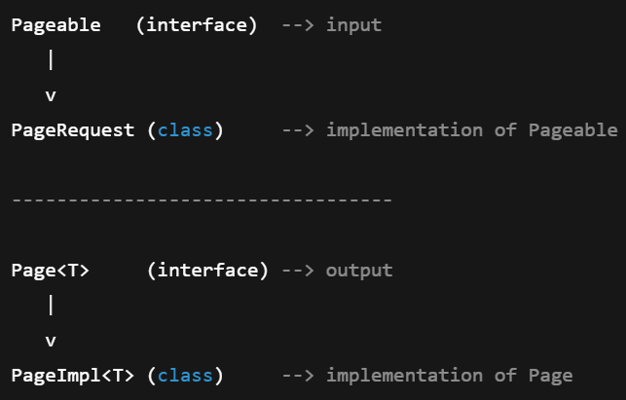
  - Pageable interface represents: page size, page number, sorting info
  - PageRequest is used to create Pageable object.
  - The query after being run returns Page object.
    - Typically we never create object of Page.
- Pageable is the interface; PageRequest is the class which inherit Pageable (not direct parent, but ancestor).
    - We need to create one Pageable object to do the pagination.
    - PageRequest is used to create the object (as of course it is the class; and Pageable type of variable can keep PageRequest type of object; because Pageable is the ancestor of PageRequest)
    - The query methods can return Page type of object (if you write return type as List then of course it’ll return List instead of Page)
- 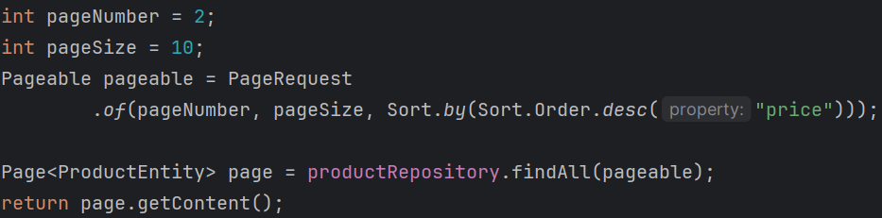
  - findAll method is already there.
  - It returns an object of type Page.
  - getContent() method is used to extract the List of Entity from the Page.

- NOTE ----------------------------------------------------------------------------------
- The return type of the query doesn’t only depends upon Pageable parameter. It depends on the return type of the method.
  - I wrote this method, and the return type is List<ProductEntity> so here List will be returned.
  - 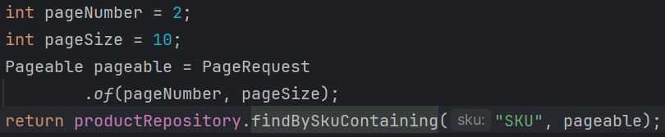
  - But if I write Page<ProductEntity> in that query then it’d have return Page type of object.
    - Now I need to use getContent() method to get the List out of the Page object.
- By default, no query method supports sorting or pagination. You need to pass Sort type of parameter to sort and Pageable type of parameter to make pagination.
- --------------------------------------------------------------------------------------------------------------
- If you return Page<ProductEntity> instead of List<ProductEntity> then you’ll get some metadata along with the contents.
- 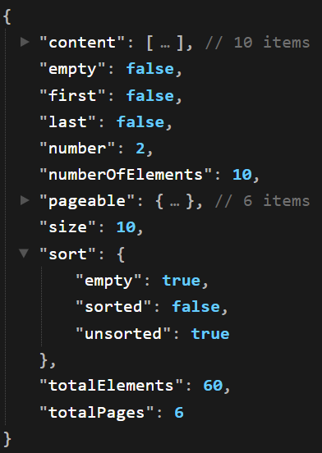 (like this)

Projection in Spring Data JPA
- A projection is a mechanism that allows you to define what data should be exposed to the caller, independent of how much data is fetched from the database.
- Returning full data can still be a projection if you are controlling what the caller can access.
- Method-1 (DTO Interface)
  - We are giving DTO directly to the repository; but as DTO interface is a view only model; so it doesn’t hamper the design pattern.
  - 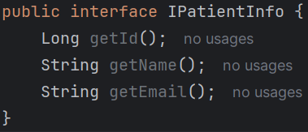
  - But there is no variables here so modification is not possible.
  - 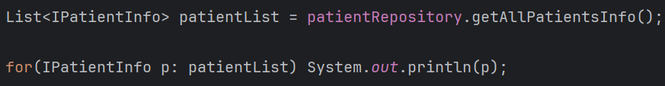
  - 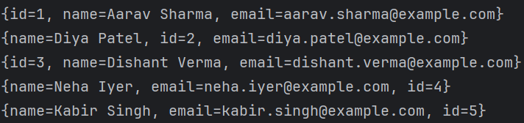
  - It’ll work.
  - In the above query i.e. “select p.id as id, p.name as name, p.email as email from Patient p” the aliases are important i.e. id, name, email,
    - id will be mapped to getId
    - name will be mapped to getName ..etc

- NOTE
  - In case of interface DTO, it doesn’t have any field. So Spring Data will not be able to create an object of this interface and return.
    - So, it creates one proxy class that implements the DTO interface.
    - Now DTO’s getter methods will be forwarded to Entity’s getter methods with the help of that Proxy.
    - Means the data you are getting is from the Entity itself.
    - 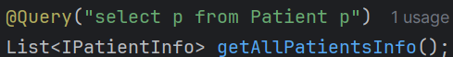
    - 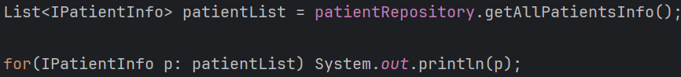
    - When you execute this, You will see entity-like output because toString() is delegated to the entity. And it is basically entity.toString() .
      - For each object, toString() call was delegated to toString() of entity
    - Printed output ≠ actual object type
    - Actual object = proxy
  - In case of class DTO (lets assume only getters are there; no setters).
    - In this case, Spring/Hibernate doesn’t need to create one proxy class because it can directly create one object of type DTO class because it’s not an interface.
    - So, in case of class DTO (even if setters are not there), the object of type DTO class will be returned; No proxy class is required here.

- This is my DTO Interface (for reference of next explanations)
  - 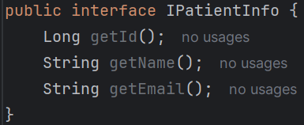
- 2 Types of projections are there:
  - Entity-backed Projection
  - Tuple-backed Projection
- Entity-Backed Projection
  - 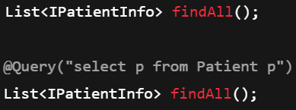
  - Both are same, if you don’t give the query then it’ll by default write that query only (which is being mentioned in the image)
  - So, here it is fetching the full entity objects which is of type Entity.
  - Flow will be like:
    - Hibernate fetches Patient Entity object from the database (As full entity has to be fetched according to the query)
    - Spring creates a proxy that implements the DTO Interface (IPatientInfo in our case)
    - Proxy holds a reference to the InvocationHandler.
    - The InvocationHandler holds a reference of the Entity.
    - Now, whenever the method will be called from the DTO will be delegated to Entity. Proxy is responsible for this.
      - dto.getName() ---- Proxy --- handler ----- entity.getName()
  - Here no data is copied;
  - No aliases are needed;
  - The data directly comes from the entity.
  - If you are wondering how it is able to know about the Entity, then you can remember we were passing Entity and Id type in the generics of JpaRepository.

- Tuple-Backed Projection
  - 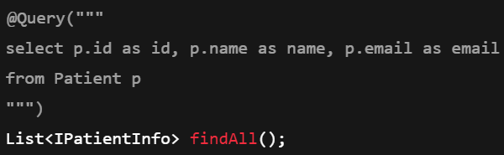
  - Here you need to give the query; and instead of fetching the whole entity, only select some specific columns that is being mentioned in the DTO interface.
  - In this case aliases are needed.
  - As here only some specific columns are being fetched from the table, so there is no need of keeping reference of Entity.
  - Flow:
    - Hibernate does not create entities.
    - Query returns selected column values.
    - Spring keeps the tuple/map inside the InvocationHandler.
    - Spring creates a proxy that implements DTO Interface (IPatientInfo in our case)
    - Proxy holds a reference of InvocationHandler (just like previous case)
    - Previously InvocationHandler was holding a reference of Entity, but in this case it is holding a reference of Map/tuple.
    - When getter is called, proxy delegates that method call to InvocationHandler, which reads from tuple/map and returns the result.
    - 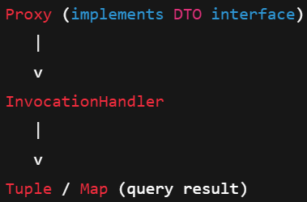

Some experiments:
- Experiment-1
  - Interface DTO (id, name, email) (IPatientInfo)
    - 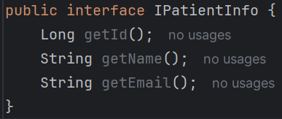
  - PatientRepository (fetching the whole entities)
    - 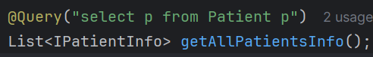
  - PatientController (returning the IPatientInfo type object)
    - 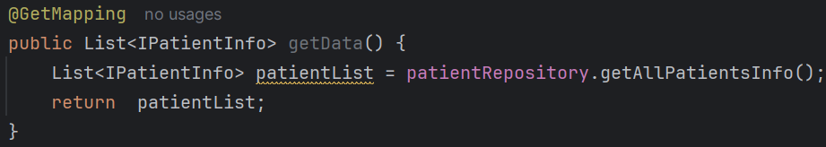
  - The response will be proper
    - 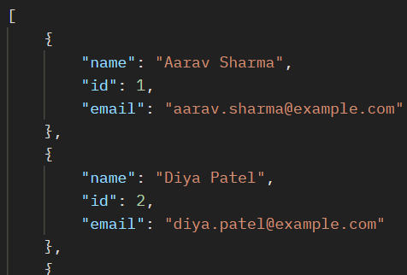
  - Reason:
    - IPatientInfo (Interface DTO) is having the getters for name, id, email which is delegated to Patient (Entity).
    - From the entity objects the getter methods are being called and the result is properly being generated.
- Experiment-2
  - Interface DTO (name, email) (IPatientInfo)
    - 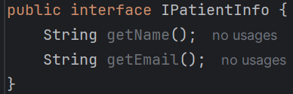
  - PatientRepository (fetching the id of the entities)
    - 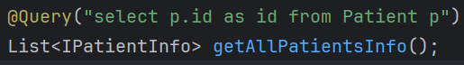
    - alias is being used for id (here getId() will be called; otherwise it’d be null without alias)
  - PatientController (returning the IPatientInfo type object)
    - 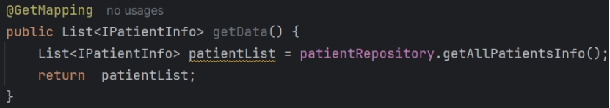
  - Now name and email will be null
    - 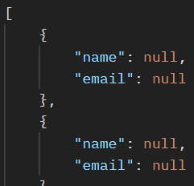
  - Reason:
    - IPatientInfo (Interface DTO) is having the getters for name, email.
    - But now getName() and getEmail() are not there because now we don’t have entity objects; rather we have map/tuple which are containing only id. So, here only getId() will work.
    - But IPatientInfo contains email, name so it is null now.
- Interface DTOs are not flexible;
  - Only one type of response can be sent.
  - The object cannot be edited as it was coming from the Map(in case of few columns) or Entity(in case of whole entity). So, Interface DTO are only view-only.
  - So, class based DTO are used which can be modified, multiple types of responses are supported.

- Class DTO
  - If the DTO class is containing only one constructor, then the JPQL query can be written normally like Interface DTO.
    - 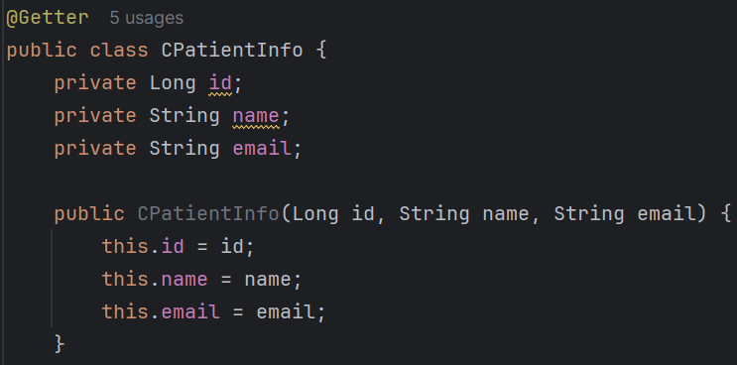(class DTO)
    - For this query, the response will be like the below:
    - 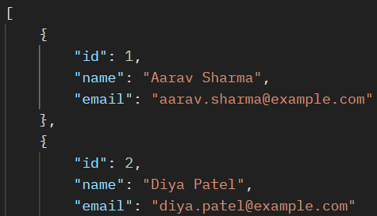(all fields are coming)
  - 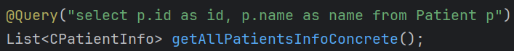
    - It’ll give “Internal Server Error” because the constructor is accepting 3 arguments but we are giving only one.
  - NOTE: In the JPQL query, the fields should be in same order as defined in the constructor; otherwise wrong fields will be passed in the constructor.
    - 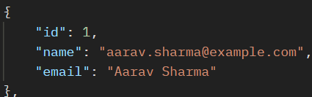(it’ll give wrong response like this)
    - If the type of fields are different then it’ll give error instead of giving response.
- So, till now we were having only single constructor, but in case of multiple constructor we need to pass the DTO class reference in the JPQL query instead of writing like this normally.
  - 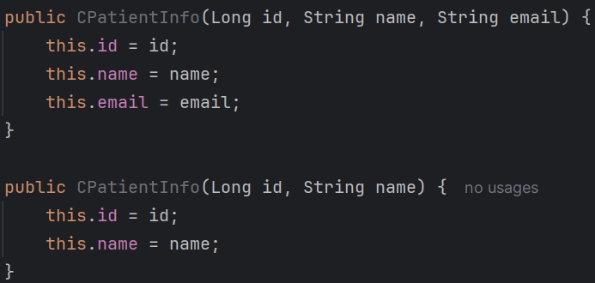
    - So now I have 2 constructors.
    - Like this you need to write.
    - new keyword is must to create object.
    - No aliases are required here.
    - 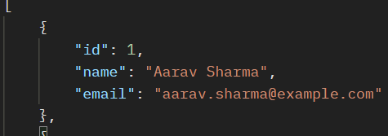(response)
  - 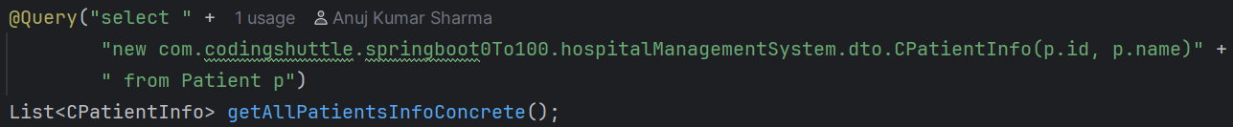
    - Here I passed just 2 fields (id and name as per the 2nd constructor).
    - 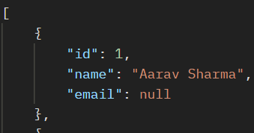
    - Now if you see, all the fields are coming but having null values.
    - To avoid that @JsonInclude(JsonInclude.Include.NON_NULL) is used.
  - 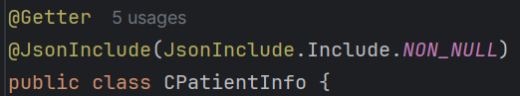
    - Now I added this here.
    - 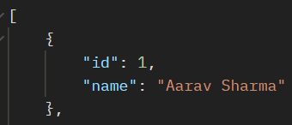
    - Now if you see, only the non-null fields are being displayed.
- Aggregate JPQL queries
  - NOTE: Aggregate functions can have aliases but those aliases should not be used for order by and group by.
    - 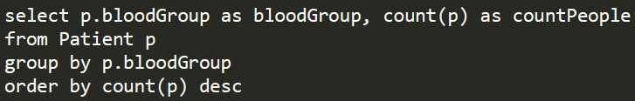
    - You can see here, I have given alias for count(p) which is countPeople but that alias name is not given on the side of order by.
    - I have mentioned count(p) on the side of order by.
    - Also, you cannot give * just like SQL query. Here you need to give the object name (p)
    - Instead of field name, p.fieldName should be given in camelCase (in db it’ll be in snake_case)
    - This is only valid for JPQL queries.
  - 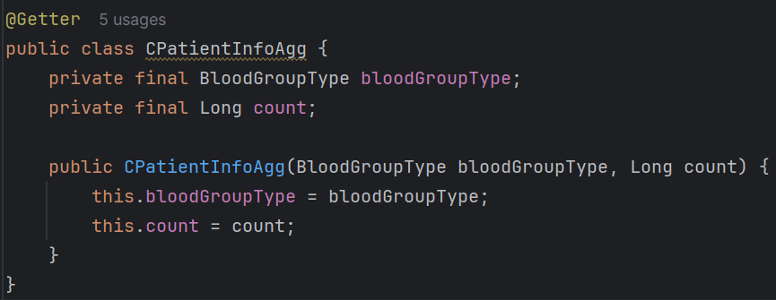
    - This is my DTO class for that aggregation query.
    - 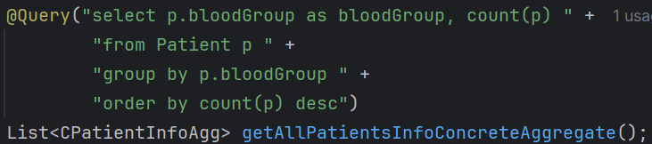
    - It’ll give the proper response.
    - 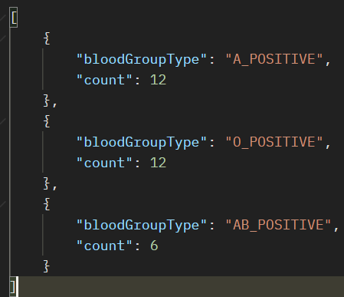
  - 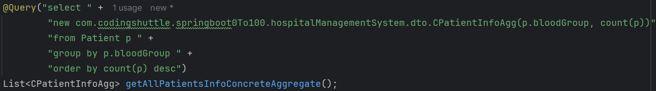
    - It is preferable to use class reference to write the JPQL queries.
- @Params is used to bind a parameter name to a particular JPQL value.
  - 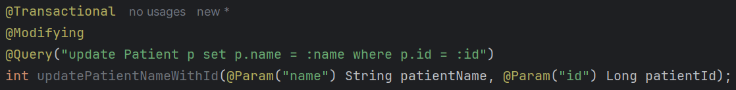
  - Here I am executing one update query.
  - You can see the parameter names are patientName and patientId but I have bound those with name and id respectively using @Params annotation.
  - And also I am using :name and :id in the JPQL query.
- @Modifying is required in case of modification of database.
  - By default Spring thinks that the query is of select type. So, it expects some data to be returned from the database.
  - Hence, it’ll read those data and give response.
  - But, in case of create/update/delete method, no data is returned; only one number of rows affected will be returned.
  - So, @Modifying will tell spring that don’t expect any data to be returned.
  - @Modifying will always go with @Transactional because you are changing the database state. And it means its involving one transaction.

Hibernate Entity Lifecycle, Entity Manager, Persistence Context
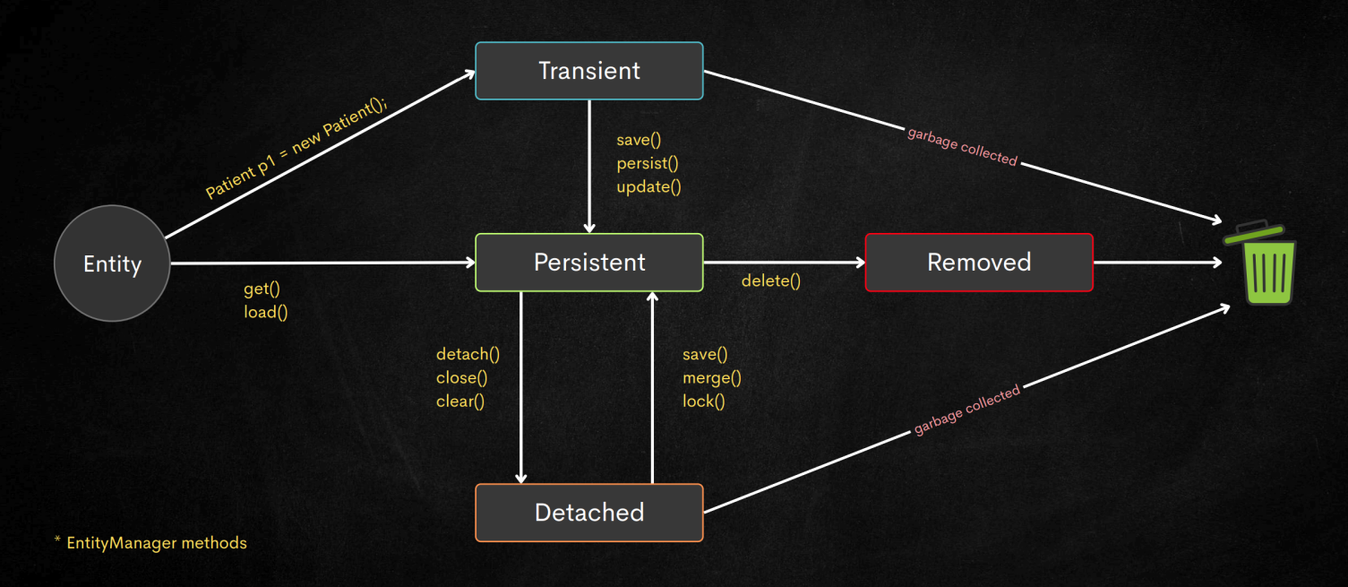
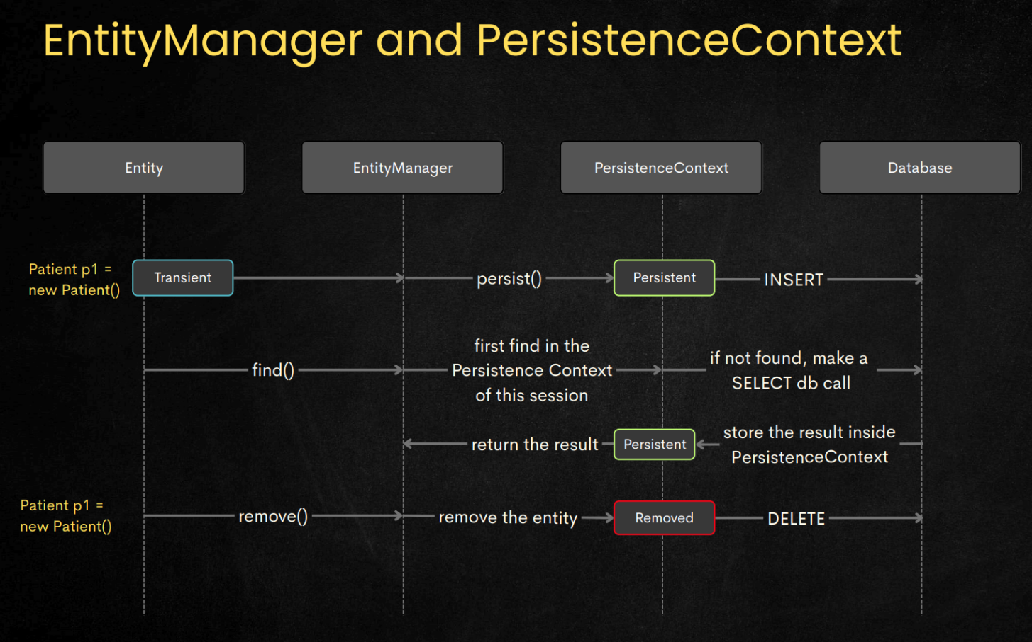
- PatientEntity p = new PatientEntity()
  - This will take the state to Transient.
  - This is only used for creating new entry.
  - So, basically only create is related to transient state, other operation (update, delete, read) doesn’t include transient state at all.
  - In transient state, it is only a pure Java object; nothing more.
  - Transient state is not managed by EntityManager; because it is pure Java object.
- Either you create one object just like above and call repository.save(p) or you are making the get call like repository.findById(id) to get the entity, it’ll be remaining in the Persistence Context only.
  - Persistence Context is nothing but a run-time state that holds all the changes being made, or data being fetched till now to reduce the number of database calls.
  - For read, it’ll check in the Persistence Context , if the entry is present then it’ll directly return; otherwise query the db, fetch the data, store the data in Persistence Context, return the data.
  - Once all the requests are being processed (it may be update, or delete, or create; because read happens directly only), when the transaction is coming to the end, it commits all the changes to the database at once. Hence reducing the number of db calls.
  - persist() puts an object into the Persistence Context WITHOUT reading from DB
  - find() puts an object into the Persistence Context BY reading from DB (if needed)
- Simple thing: if the operation is of type create, update, delete, then it’ll keep all the operations within it; and when the transaction ends it trigger those queries to db.
- If the entity is made Detached and left hanging there in the Transactional method; and after that method ends if the reference of the entity is destroyed; then the entity will be garbage collected.
- Same for remove and transient(create) as well;
- Means its normal Java concept; if the variables that were holding the reference of the entity object are destroyed; then the entity object will be garbage collected; it has nothing to do with the transient or persistence or detach state.
- IMPORTANT: @Transactional is required to make proper use of Persistence Context. If @Transactional is not mentioned, then there is no guarantee that each method will run in same Persistence contexts.
- Some Points to Remember
  - Repository object will be having EntityManager’s methods.
  - JpaRepository will be implemented by SimpleJpaRepository class.
  - SimpleJpaRepository class will call the methods of EntityManager.
    - (Hibernate implements the EntityManager interface)
  - So, we call the methods like
    - repository.save(entityObject)
    - So, under the hood it is called like
    - entityManagerObject.persist(entityObject)
  - persist for create, merge for update, delete for remove.
  - 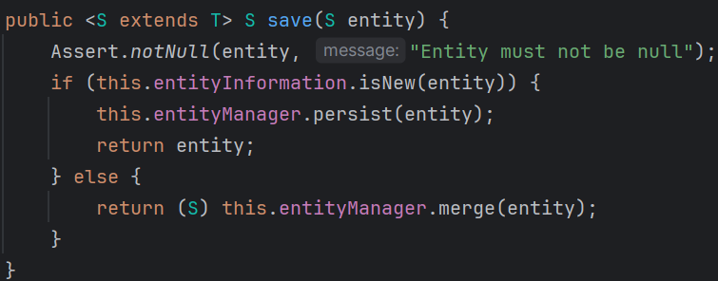
    - It’s the SimpleJpaRepository class’s save method.
    - If it is isNew then persist else merge for update.

- Garbage Collection
  - Garbage Collection is purely a Java concept
  - objects are created inside heap
  - As variables are created on stack so after the execution of their respective scope, those variables will be destroyed.
  - So, when all the variables holding reference to an object are destroyed or cleared, and there is no variable present which is containing the reference of that object so that JVM can reach that object, then the object will be eligible for garbage collection.
  - JVM can not reach the object means: JVM is not able to find any variable(normal or static or anything) that contains the reference of the Object. So, the reference of the object is lost now. So In that case JVM send the Object for garbage collection.

Relationship Owning side and Inverse Side

- In every bidirectional JPA relationship, exactly ONE side must be the owner.That owner is the side that contains the foreign key in the database.
- How to know which is OWNING and which is INVERSE?
  - Just find out where should the foreign key can be stored?
  - Normally the decision making will be like:
    - For 2 entities entity-1 and entity-2
    - If entity-1 can exist without entity-2 then entity-2 should contain the foreign key (i.e. primary key of entity-1); so entity-1 is inverse and entity-2 is owning.
      - One catch will be here; lets say 2 entities are there user and profile.
      - user can exist without profile but vice-versa is not true.
      - So, profile should contain the FK.
      - But, its upon USER’s decision that he’ll create his profile or not so in this case PROFILE can be null as well.
      - So, in this case it is better to keep FK in user table instead of profile.
- One-To-One mapping in JPA
  - Lets say USER and PASSPORT.
  - PASSPORT is the owning and USER is the inverse.
  - inverse side will contain mappedBy in JPA.
  - @OneToOne
    - It’ll tell Hibernate that I need one foreign key column in my table.
    - If you pass mappedBy then it’ll think that “okay, my other half has already kept me; I don’t need to keep that”
    - without mappedBy hibernate thinks this is the owner. If you don’t write mappedBy in neither of 2 entities (User and Passport) then it’ll create foreign key column in both.
    - mappedBy will contain the variable name (of object; not database column) which is created in the owning side as the value.
      - 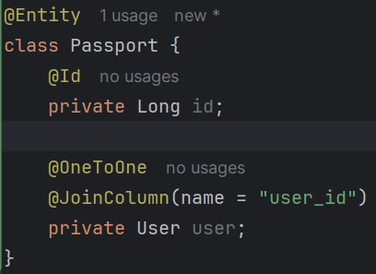
        - Here owning type has variable name: user
      - 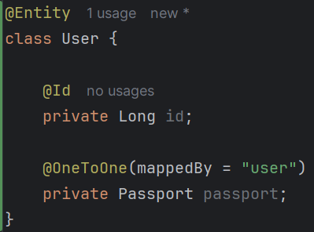
        - So, user has to be given as the value of mappedBy in inverse.
  - @JoinColumn
    - it is just used to provide name of foreign key column; if you don’t give this annotation then by default the column name will be like the below:
      - Let inverse table is Person and id field is myPmId
      - The column name would be: person_my_pm_id. (if @Column doesn’t contain any different column name; else that column name will be created)
    - @JoinColumn(“person_id”) it means nothing but “store the primary key of inverse table in my table as foreign key under the column having name person_id”
    - Means the foreign key column will be named as person_id.
    - In case of person_id I can even right @JoinColumn(“lalala_lululu”)
- One-to-Many or Many-to-One mapping in JPA
  - Many side will always be the owning type; hence foreign key will be there in the Many side only.
  - Many side:
    - @ManyToOne
    - @JoinColumn (if you want a personalize column name)
  - One side:
    - @OneToMany(mappedBy)
- Many-to-Many mapping in JPA
  - This is slightly different than the previous mappings.
  - Here No FK in either of tables.
  - Relationship will be stored in another table.
  - Any table can be owning and other will be inverse (its completely up-to you)
  - 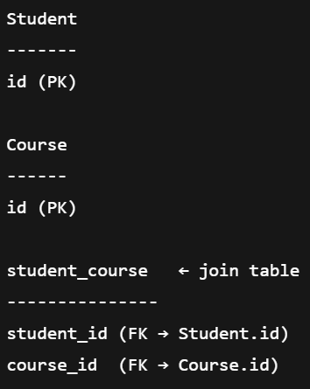(Student, Course)
  - I chose Student as the owning type.
  - 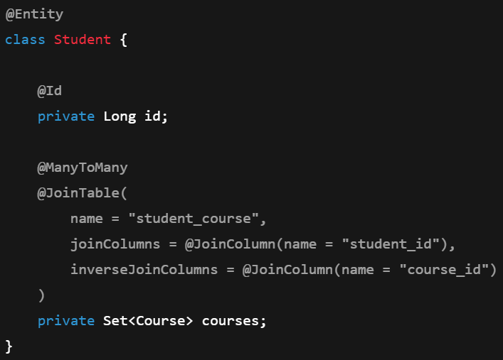(owning)
    - Here @JoinTable is used; inside which @JoinColumn is used.
      - Again, here also @JoinColumn is not mandatory.
  - 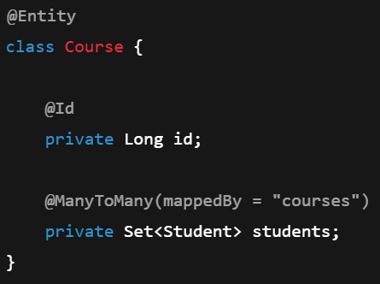(inverse)
  - 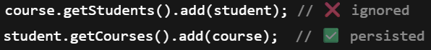

Cascading
- It tells persistence provider (Hibernate) what operations to propagate from a Parent entity to Child entity.
- NOTE: owning and inverse are no way related to parent entity and child entity concept.
- The orphanRemoval and cascade are written in Entity level. If you call the method like deleteById it is not guaranteed that those cascade will be used.
  - You need to call the method delete() which take an entity object as the argument.
- cascade vs orphanRemoval
  - cascade means if some operation is being executed on parent entity (create, update, delete) then the same operation will be executed on child entities.
  - orphanRemoval means if the reference is gone, then delete the object that was being referenced (just like GC in Java)
    - 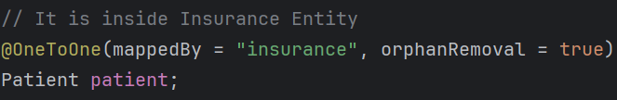
    - If I set patient=null for the insurance entity object, and if there is no entity that has reference of that particular patient entity object, then that entity will be deleted.
    - In simple terms, when an entity becomes orphan (no parents are there), then it’ll be deleted.
    - Its independent of owning/inverse concept.
  - Simple analogy:
    - cascade : if I am being punished, all my children will also be punished.
    - orphanRemoval : I don’t want my children now; if no one has made them their children then remove them.

- NOTE
  - In case of cascade or orphanRemoval, even the repository method will not be able to manage the transaction properly.
  - So, its better to use @Transactional in the method when doing CUD (create, update, delete) operations.
  - If the parent function contains @Transactional, and the child function (being called in the parent function) is also having @Transactional, then also it won’t give error. It is good practice to use @Transactional
    - 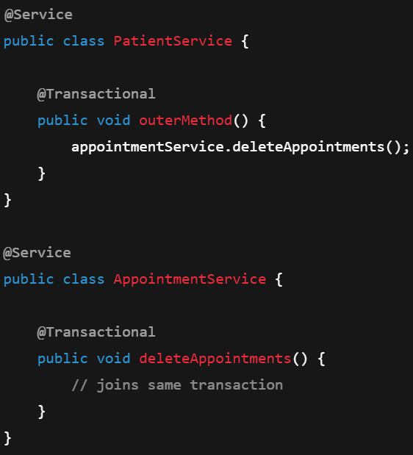
    - Its safe.

- 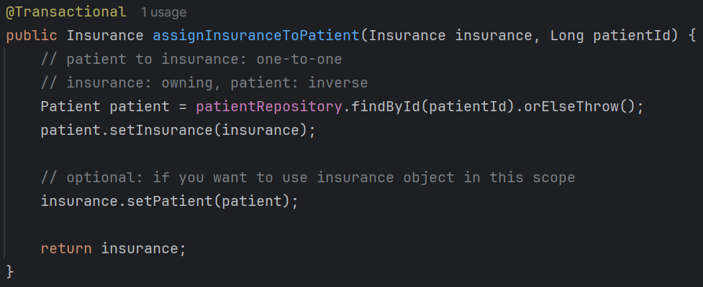
  - Here this service method is assigning one insurance to the patient.
  - @Transactional is required to make these whole queries run in a single persistence context.
  - If you remember, without @Transactional, all the method may not run in same persistence context.
  - 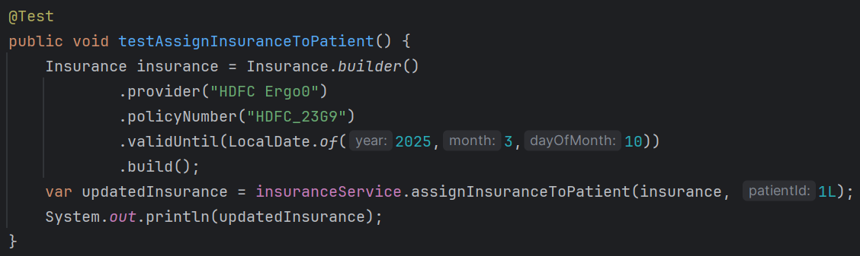
    - It is the test method; but it’ll fail because we have not made the patient entity as cascade yet. So, even if the patient is created, it’ll not create the insurance.
    - 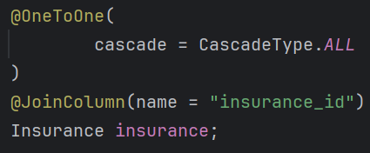 NOW IT WILL PASS
    - (or)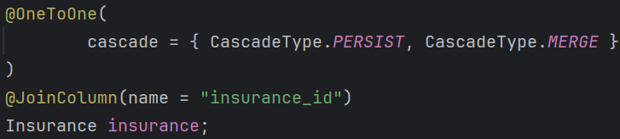

- There are 2 sides: owning & inverse.
  - As we know owning side will contain the foreign key.
  - So, if you try to delete the inverse entity then it’ll not happen; because it is being referenced in another table (owning table)
  - You cannot delete the inverse side of a relationship while the owning side still points to it.
- Some points to be remembered:
  - orphanRemoval on inverse side is of no use;
    - Because, inverse side doesn’t have a solid foreign key column;
    - If just keep one reference of the owning entity to fetch the data and store there;
  - cascade doesn’t care about owning/inverse. It’ll execute all the operation, that is being executed to the parent entity, to every child entities whose references are there in current entity.

- orphanRemoval example
  - 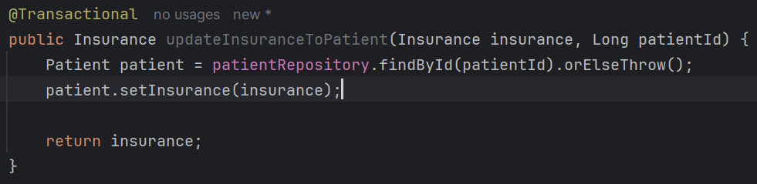
    - Here I am updating the insurance.
    - So, previous insurance object became orphan, hence it’ll be deleted.
    - new insurance object will be created, saved; then it’ll be added to patient.
  - 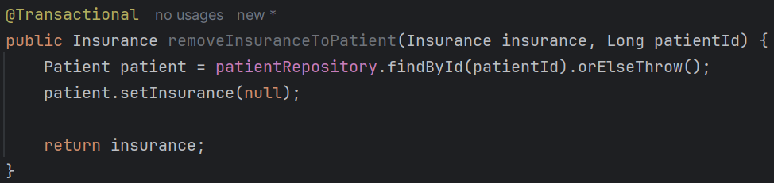
    - Same here as well; in stead of changing the insurance, here insurance is being removed;

- 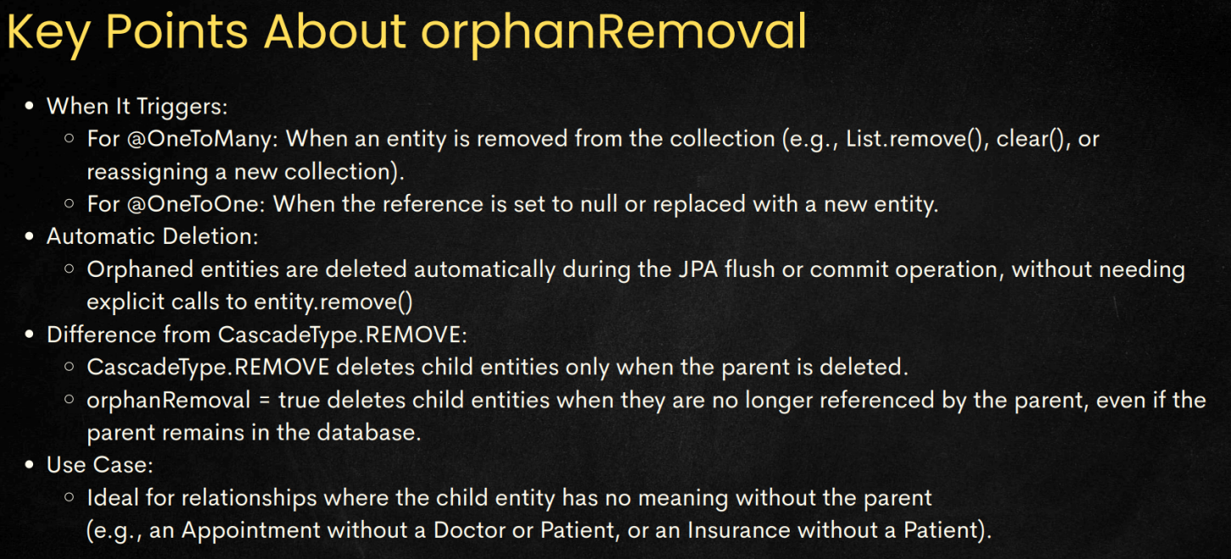
- 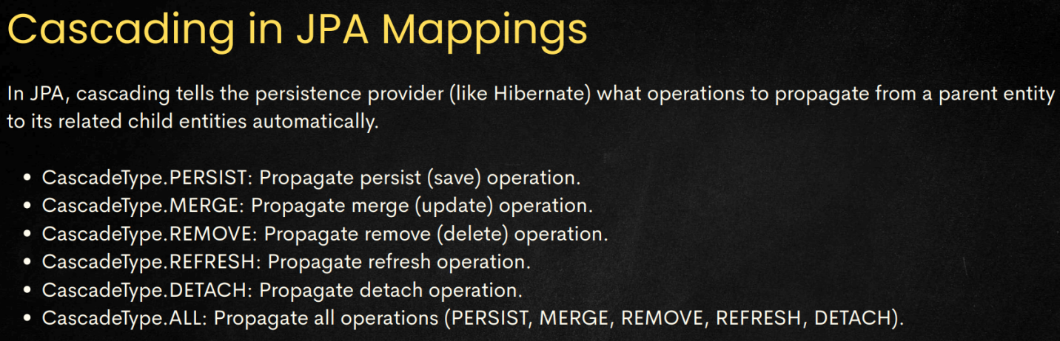
- N+1 Query Optimization
  - For one to many relations, the entity having one-side will be having a List of the entities of many-side.
  - In this case, by default the fetching behaviour is Lazy.
  - If you want to get all the things within the same object directly then you can use:
    - fetch = FetchType.EAGER (eager means it’ll directly call join query and give you one object having all the objects of the referenced type(s))
  - When you make this FetchType.EAGER, you can see there will be N+1 queries; which is not optimized behaviour;

- FetchType
  - 2 types are there: EAGER, LAZY
    - In case of EAGER, child will be loaded immediately when parent is fetched.
    - In case of LAZY, child will only be loaded when we do get call from parent to get child data.
  - But sometimes we want both;
    - Like some method call may need full data i.e. parent and child in a single call.
    - And some method may not need full data; in this case making the Entity as EAGER will be very expensive; unnecessary a lot of data will be fetched from DB.
  - So, in this case we make the Entity LAZY and we’ll do something in method call to control the type of fetching.
    - One thing can be done:
      - Fetch the parent
      - Use a loop or something like that to get all the child objects;
      - But, it’ll result in N+1 SQL queries; 1 for fetching parent, N for fetching children (considering N childs are there)
    - Instead of handling the FetchType from the Entity level, we’ll do this from method level.
    - So, when the method needs full data EAGER type call will happen; otherwise LAZY by default;
  - 2 methods of controlling the fetching type from methods:
    - FETCH join JPQL query
      - 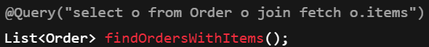
    - @EntityGraph annotation
      - 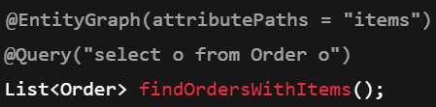
      - “items” is object field name; not column name;

Some Experiments
- Lets say 3 entities are there E1, E2, E3; some objects are e1, e2, e3.
  - E1 to E3 : One-to-One mapping
  - E2 to E3 : One-to-One mapping
  - orphanRemoval is true for E3 field in both E1, E2.
  - Lets say I did: e1.setE3(null)
    - Just removing the reference of e3 from e1.
  - But, e1’s reference is still there in e2.
  - But, in this case Hibernate will try to delete e3 from DB because in e1, its reference is gone.
    - Then DB will give error saying its reference is still there in E2 table.
  - So, its design failure; The design of Database is wrong here;
- Let say 2 entities are there E1, E2. ------ this is wrong; not sure why it happens -----
  - E1 to E2 : One-to-One
  - orphanRemoval is true for the E2 field in E1 entity.
  - No cascade is there.
  - Lets say I delete e1 (object of type E1) which had reference of e2 (object of type E2).
    - Even there is no cascade there, but because of deletion of e1 the reference of e2 is gone; hence it’ll delete e2 as well.
- Ff

Some Error Causes
- ERROR-1
  - Consider the following codes:
    - 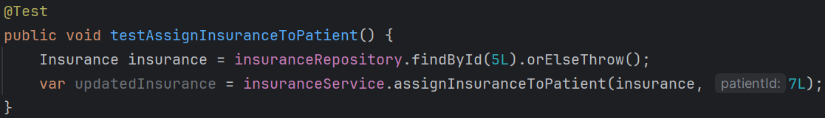
    - 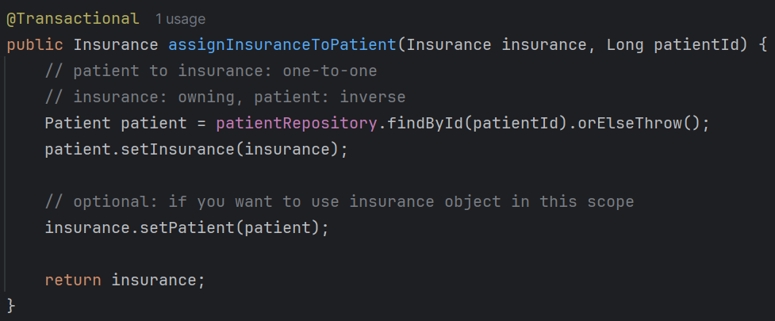
  - In this case you’ll get an error like: “detached entity passed to persist”
  - In the first method i.e. testAssignInsuranceToPatient,
    - you are using findById to get the insurance.
    - So during this method call:
      - Spring opens a short lived EntityManager
      - Loads Insurance
      - Returns it
      - Closes the EntityManager
    - Now, as the EntityManager is closed, so now insurance is in detached state now, not in managed (persistent context) state.
    - Now you are sending this detached object to next method i.e. assignInsuranceToPatient which is passing this object to setInsurance.
    - So, in here, setInsurance expects one managed state object; but its gettnig detached state object;
    - Hence, it is giving that error.
  - Fix:
    - write @Transactional in the @Test method; Now, both the method will run in same EntityManager till the transaction is completed.
    - If you are writing @Transactional in @Test method, then no need to write @Transactional in the assignInsuranceToPatient method. Only the outer method needs to have @Transactional.

